

**MARUZI SEED SECONDARY SCHOOL**

**END OF TERM II EXAMINATIONS 2023**

**S.1 MATHEMATICS**

|  |  |  |  |
| --- | --- | --- | --- |
| **STUDENT’S NAME** |  | **STREAM** |  |

**INSTRUCTIONS**

* Write your name in the box at the top page
* Answer all questions in section A and any two from section B
* All questions carry equal marks
* Answers to section are to be written in the spaces provided and section **B** in the answer sheets
* You must show all necessary working clearly
* Any additional question(s) answered will not be marked.

**SECTION A**

1. Write seventeen thousand seventeen in figures

……………………………………………………………………………………………………………………………………………………………………

1. Simplify 3×.

………………………………………………………………………………………………………………………………………………………………………………………………………………………………………………………

1. Work out 16 ÷-2+8 –3.

……………………………………………………………………………………………………………………………………………………………………

1. Write 3003003003 in words.

……………………………………………………………………………………………………………………………………………………………………

1. Work out 242five – 34five.

………………………………………………………………………………………………………………………………………………………………………………………………………………………………………………………

1. Identify the place value of each digit in 4214six.

……………………………………………………………………………………………………………………………………………………………………

1. Given that 34n = 112four, find the value of n.

………………………………………………………………………………………………………………………………………………………………………………………………………………………………………………………

1. Express 0.65444… as a fraction.

………………………………………………………………………………………………………………………………………………………………………………………………………………………………………………………

1. Construct a perpendicular bisector of the line below.
2. Write the triangular number in position three.

…………………………………………………………………………………………………………………………………………………………………....

**SECTION B**

1. Study the map below and state the compass points of the following from the assembly ground.
2. Security room
3. Stor room 2
4. Classroom 3
5. Toilets
6. Star cases
7. Stor room 1

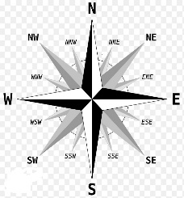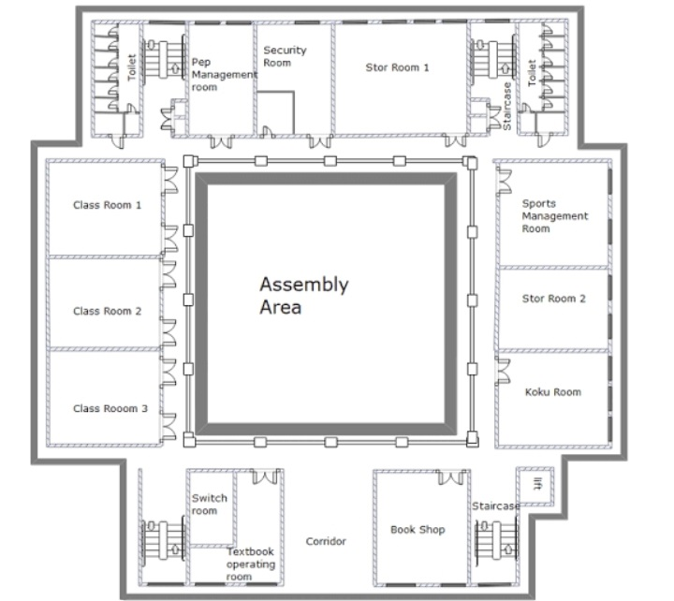

1. 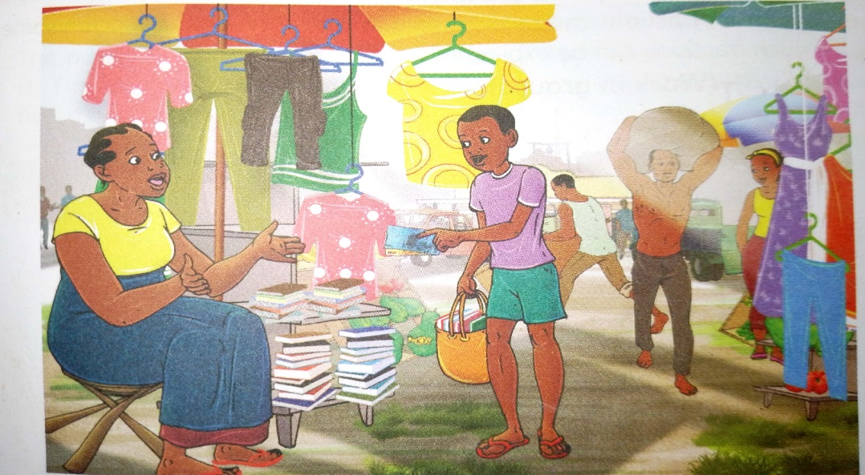A student went to Arocha market with UGX 64000. He spent of his money buying books and of the remainder on open shoes.

What fraction of the total money did he spend in the market?

1. State the coordinates of the following points A, B, D, E, F, G, J, K, M, N.

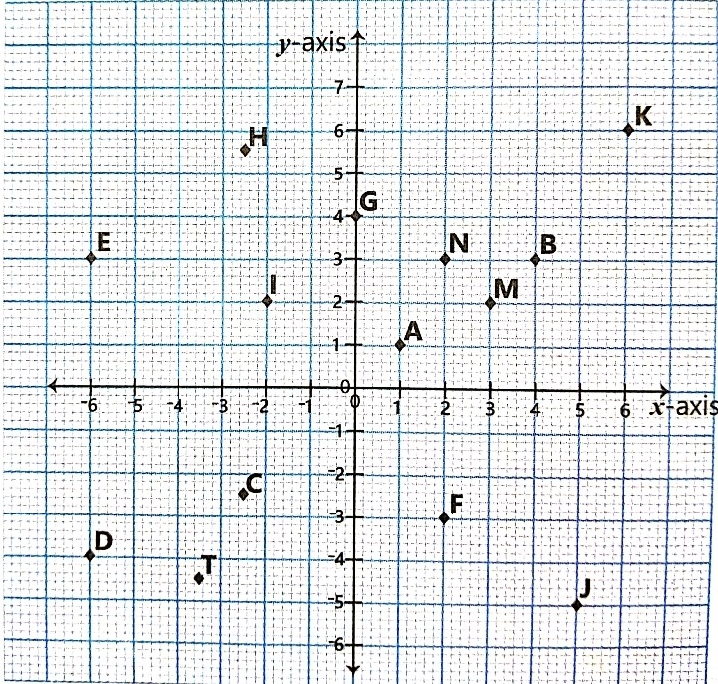

**THE END**